UNIX COMMANDS:
pwd – present working directory
mkdir- to create a directory (make a directory)
rmdir- Remove a directory
cd- change a directory (or move to the directory)
cd ..- go to the back
cd ~ - Go to home directory
touch – to create a empty file
cat - to create a file with text
echo – to create a file with text
gedit – to create a file and edit the content
vi editor- to create a file and edit the content
nano editor- to create a file and edit the content
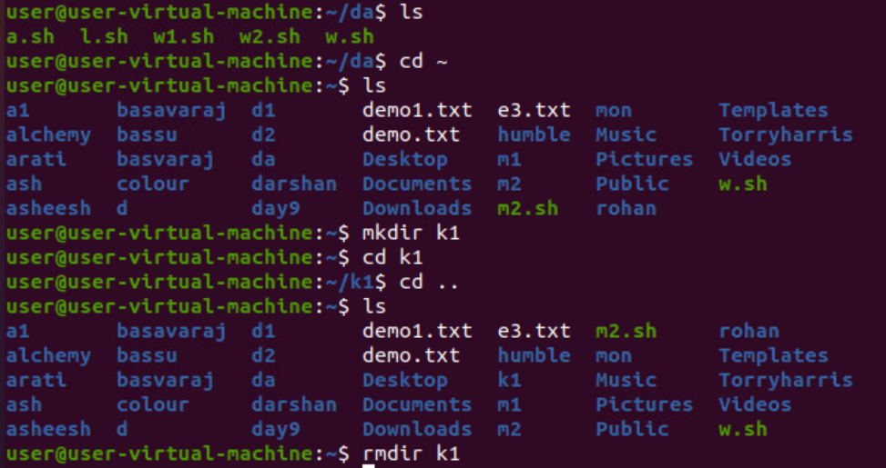
.
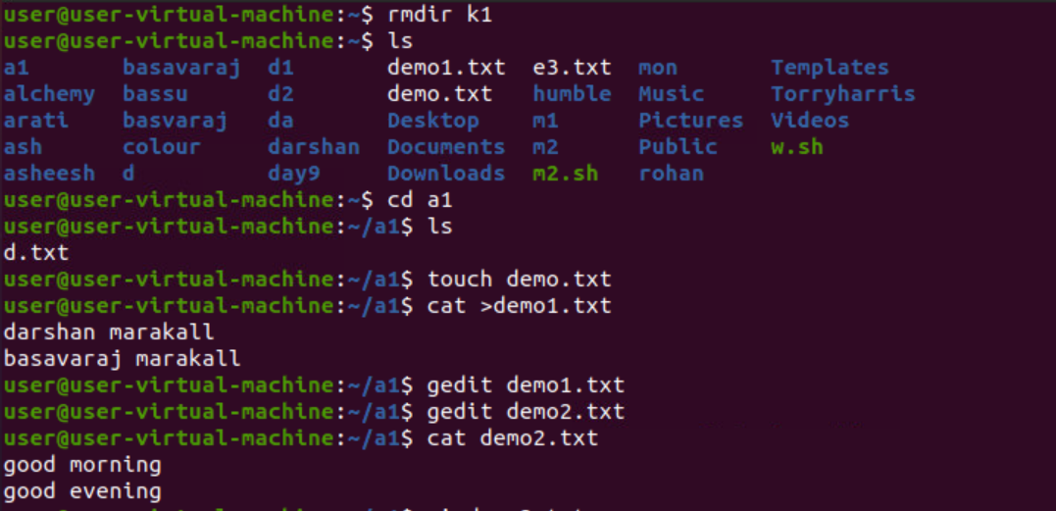

.
LS COMMANADS:
ls -p, ls -r, ls -s, ls --help, ls -l, ls -t, ls -T, ls -g, ls -G, ls -o.

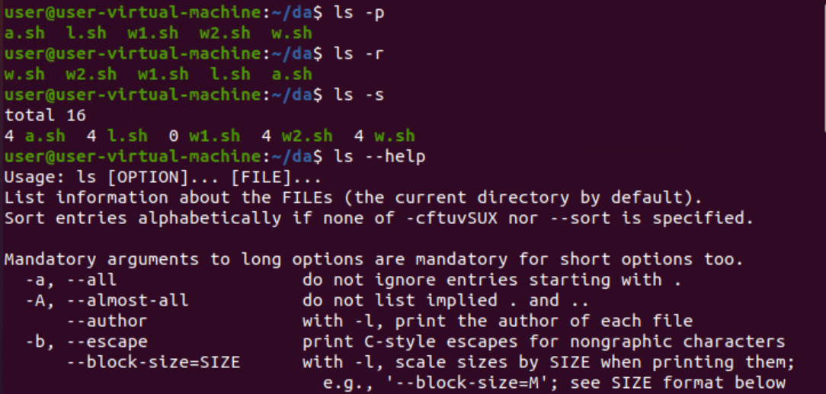
..
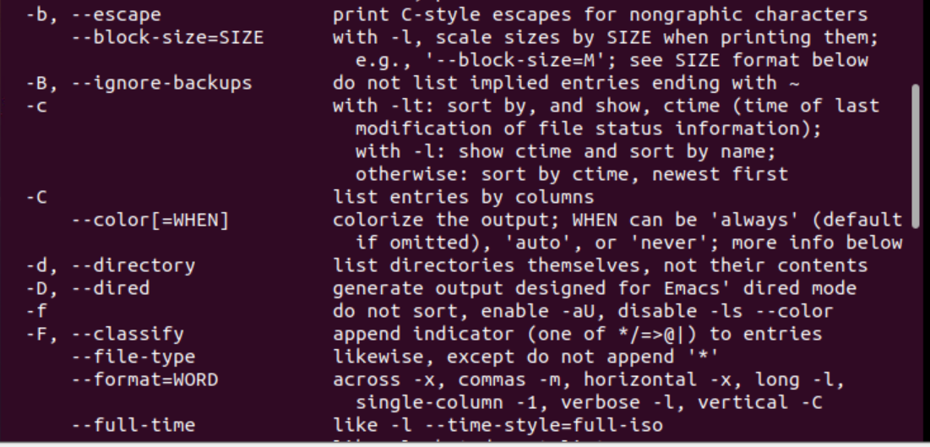
..
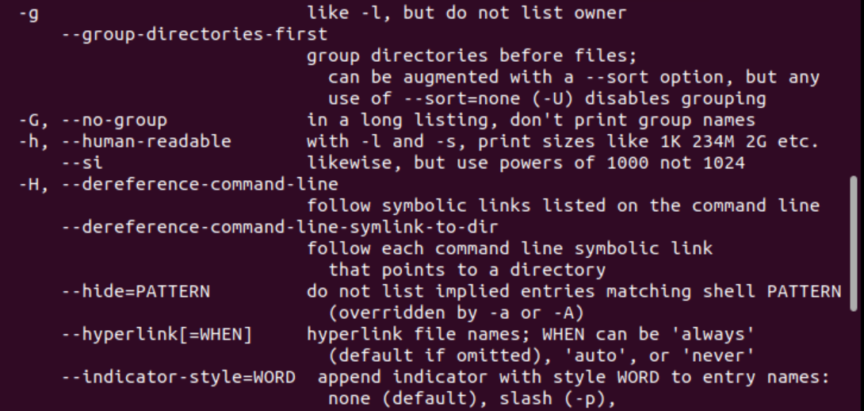
..
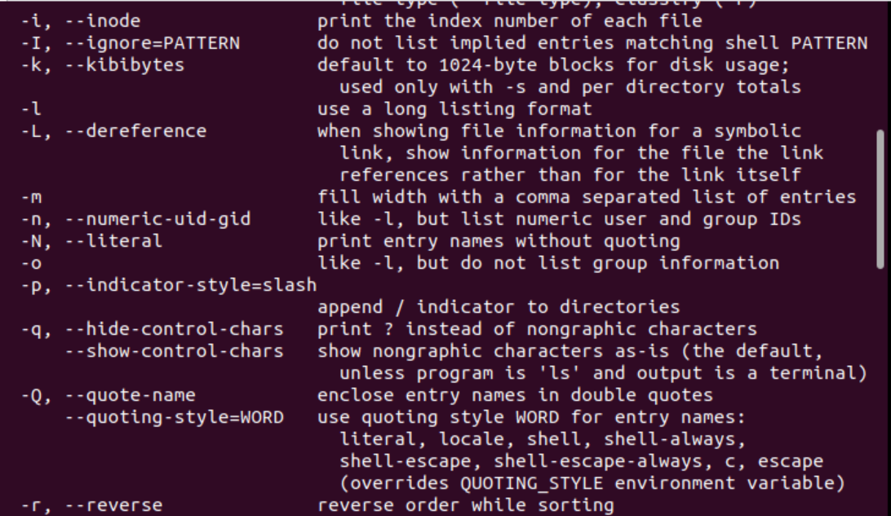
.
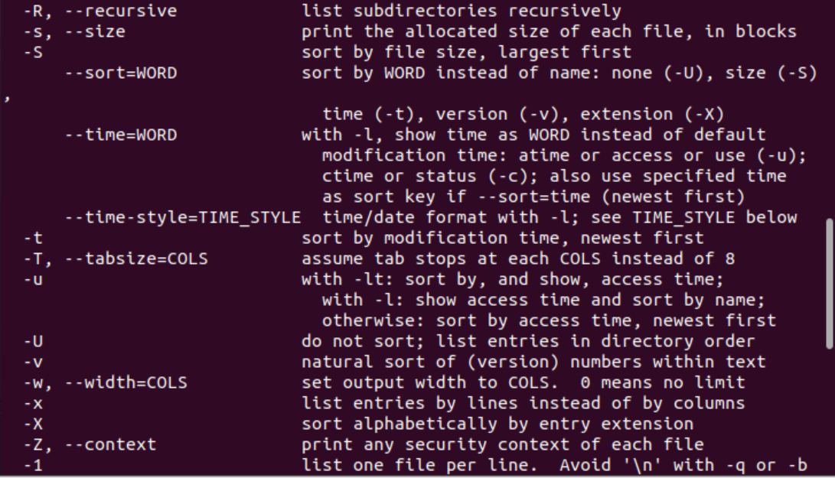
.
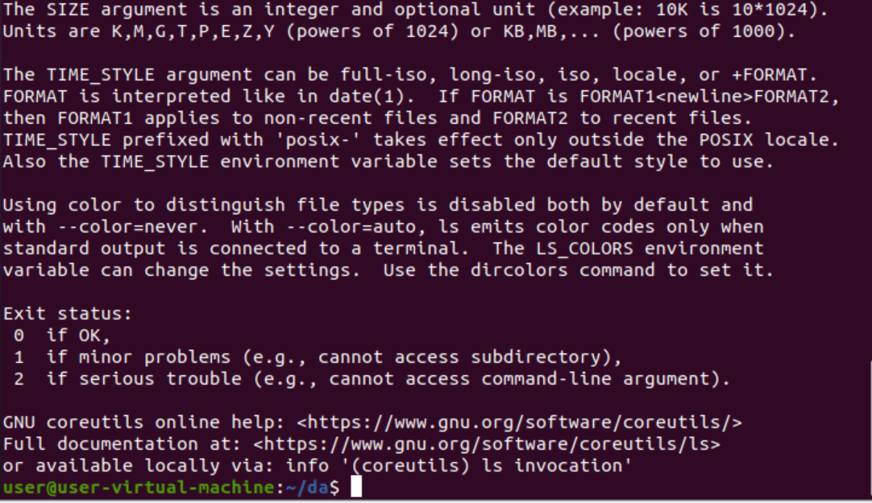
.
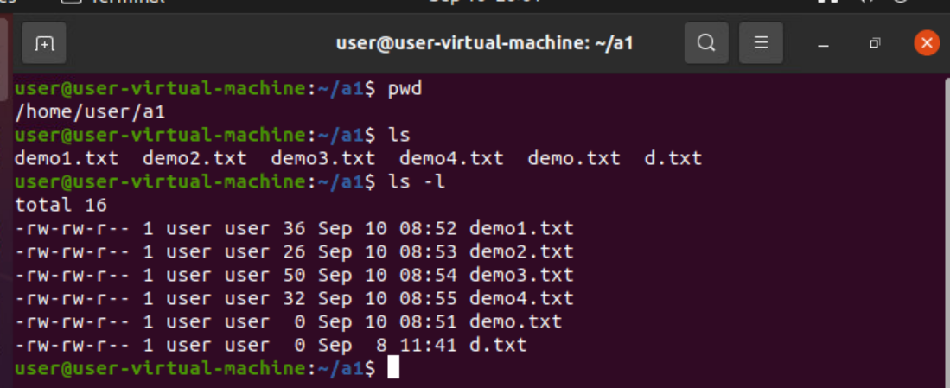
COPY
using cp command we can copy the file or directory(source) into another file/directory(destination )
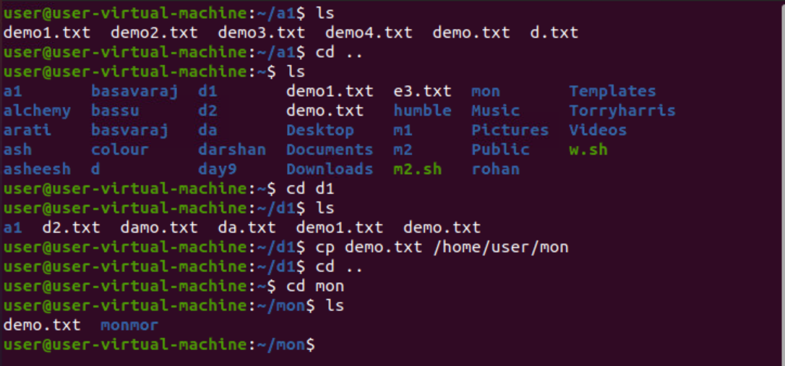
.

Cp -r (cp with -r will help in copying of one directory to another directory, where as it will copy all the files in the source directory to destination directory)
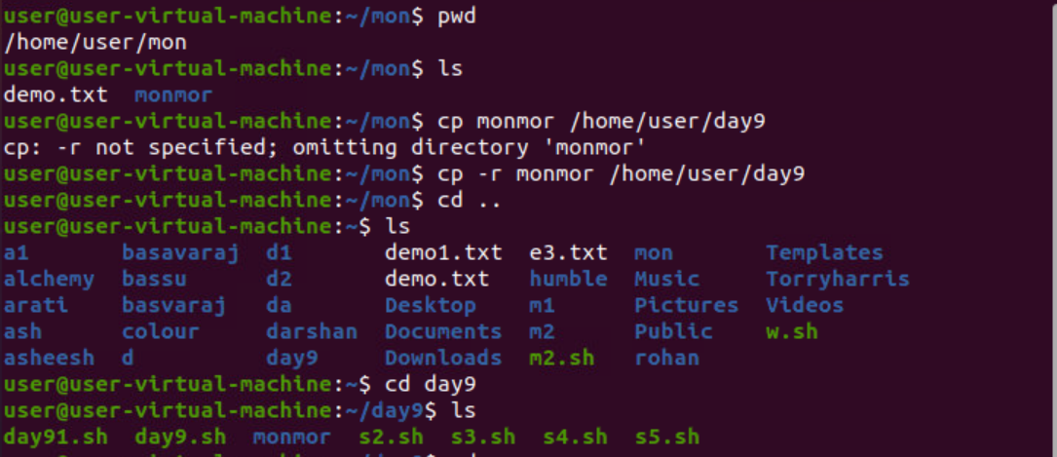
.
cp -i (this commands will give the message for overwriting the file ,if we press y the it will overwrite otherwise not )
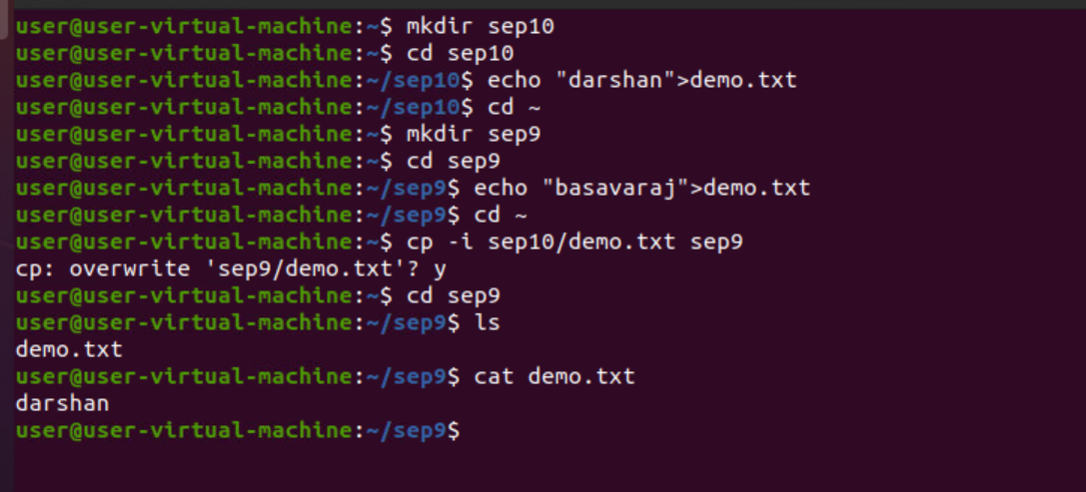
.

cp -b(this command will create the backup file in the destination directory/file(that backup file will have extension of ~ symbol))
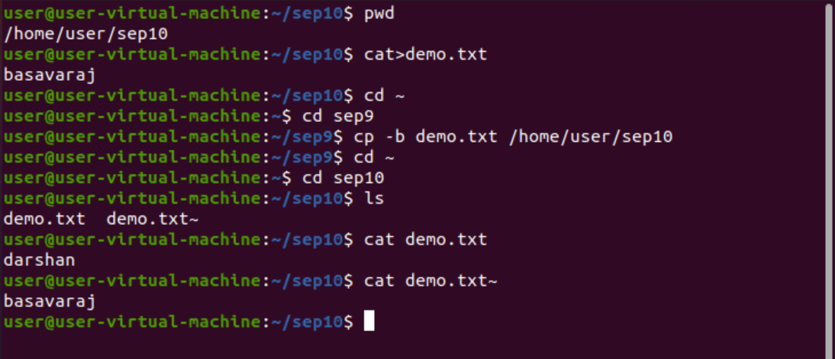
.

cp -f( this command will forcefully copy the file into another file without asking any permission for overwrite)
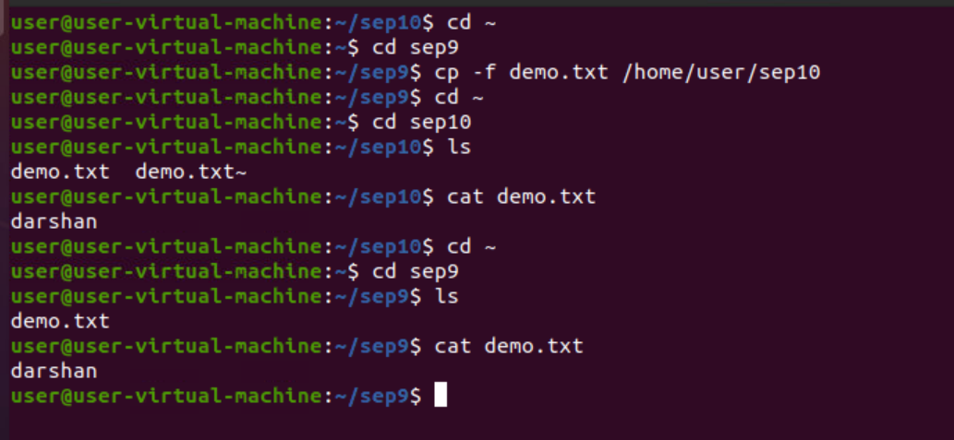
.

MOVE: using this mv command we can move the file/directory from source to destination. But here the source file will be deleted. If you want the source file backup, in that case you can use backup option i.e mv -b
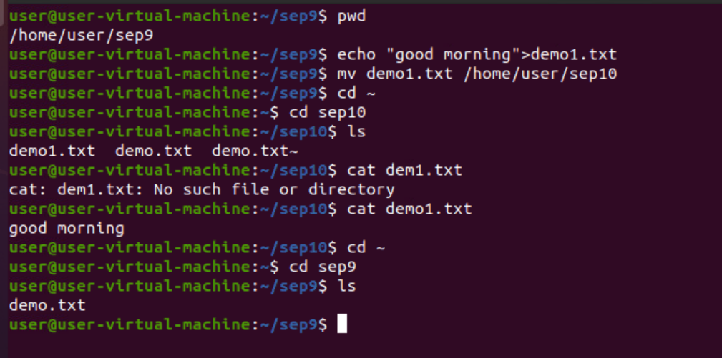
.
mv -i -(this commands will give the message for overwriting the file ,if we press y then it will overwrite otherwise not )
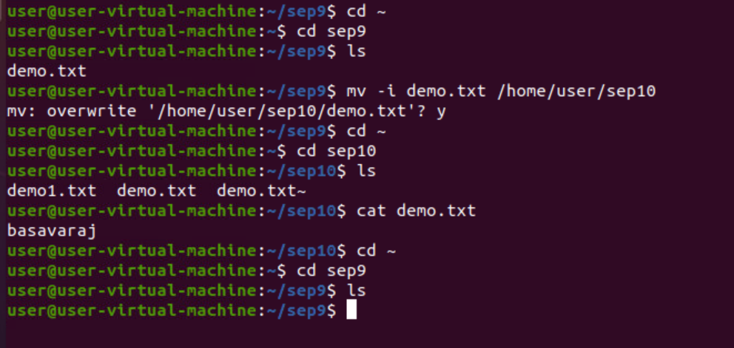
.

mv -f(forcefully moved the file from source to destination)
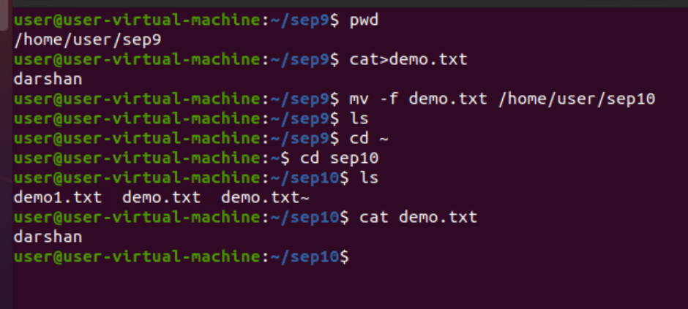
.mv -b(backup file will be created in the source)
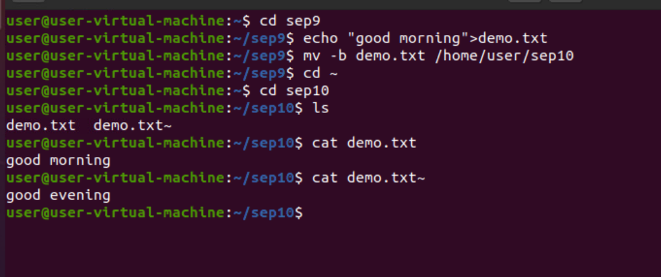
.

GREP(globally search for regular expression): it is a filter which is used to searches a file for a pattern of characters, and displays all lines that pattern.
grep -i = Ignores, case for matching
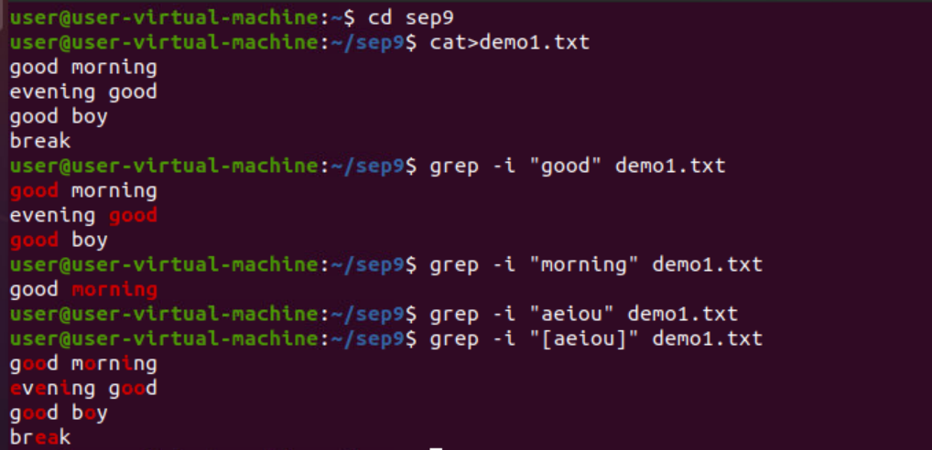
.
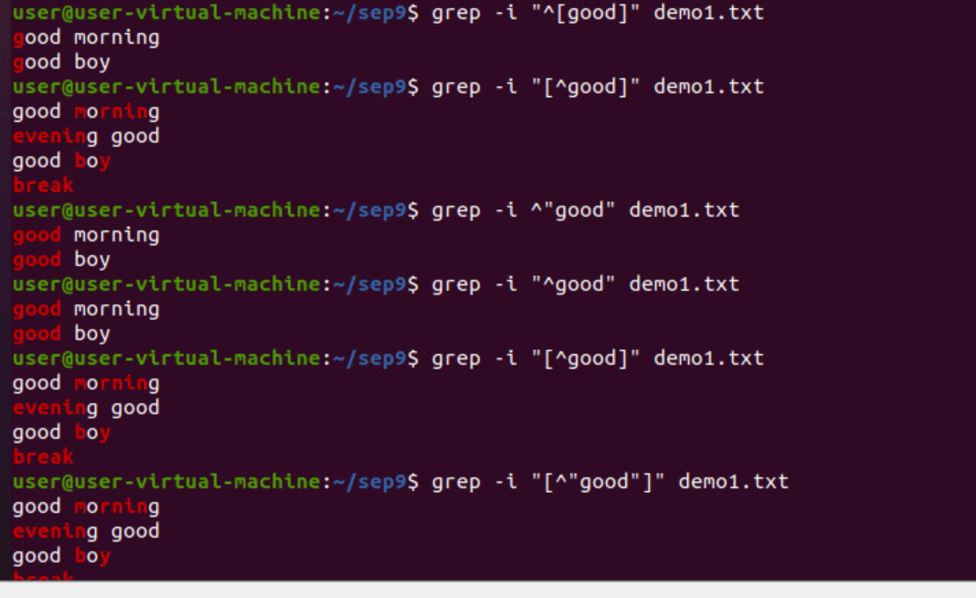
.
grep -c =This prints only a count of the lines that match a pattern
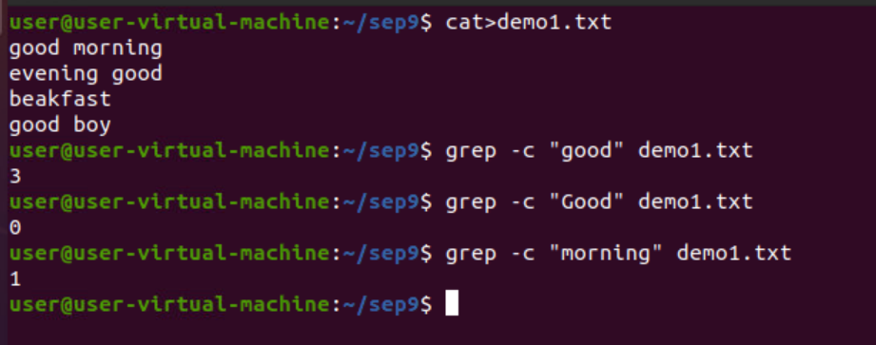
.

grep -h =Display the matched lines, but do not display the filenames.
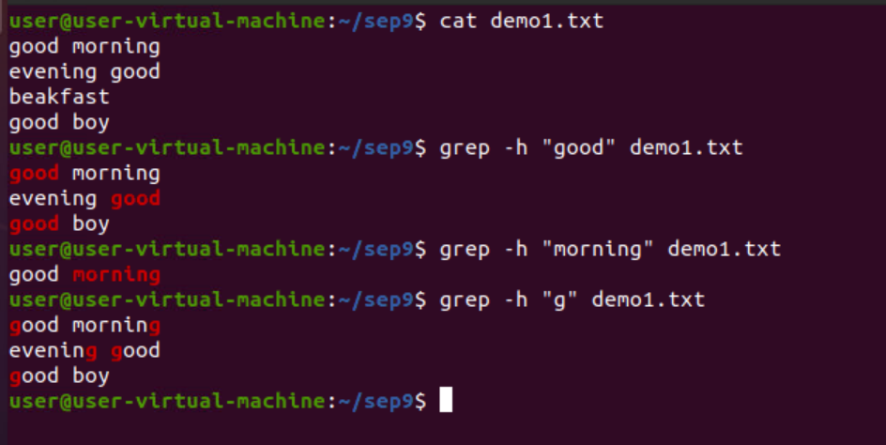

CUT: The cut command in UNIX is a command for cutting out the sections from each line of files and writing the result to standard output. It can be used to cut parts of a line by byte position, character and field. Basically the cut command slices a line and extracts the text. It is necessary to specify option with command otherwise it gives error. If more than one file name is provided then data from each file is not precedes by its file name.
cut -b = -b(byte):To extract the specific bytes, you need to follow -b option with the list of byte numbers separated by comma. Range of bytes can also be specified using the hyphen(-).

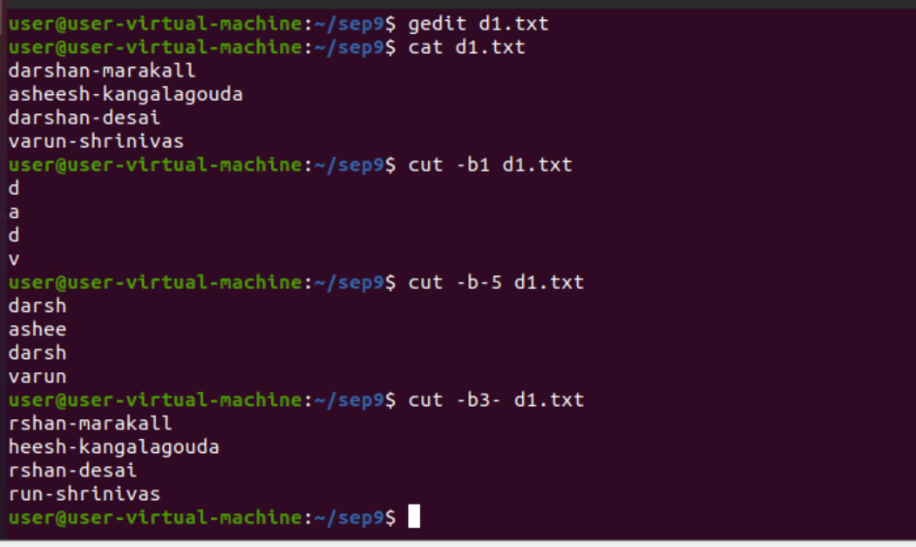

cut -c = -c (column): To cut by character use the -c option. This selects the characters given to the -c option. This can be a list of numbers separated comma or a range of numbers separated by hyphen(-).
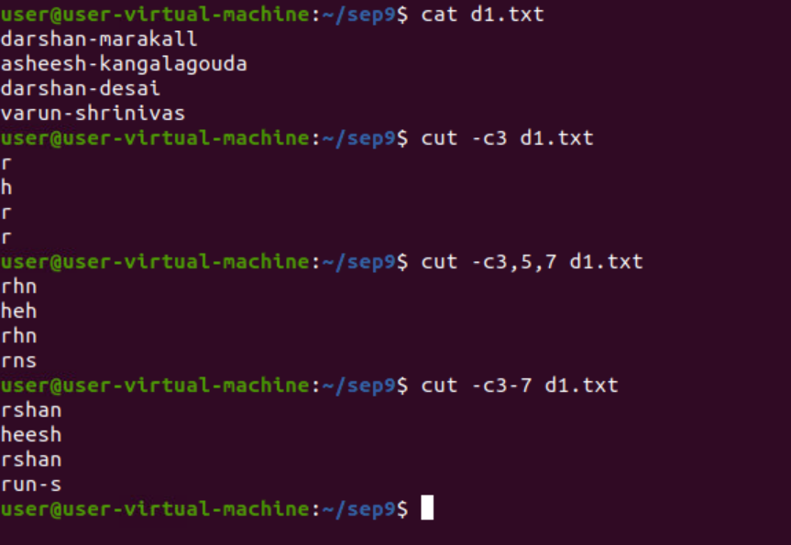
.

cut -d (delimiter) ,-f(field)
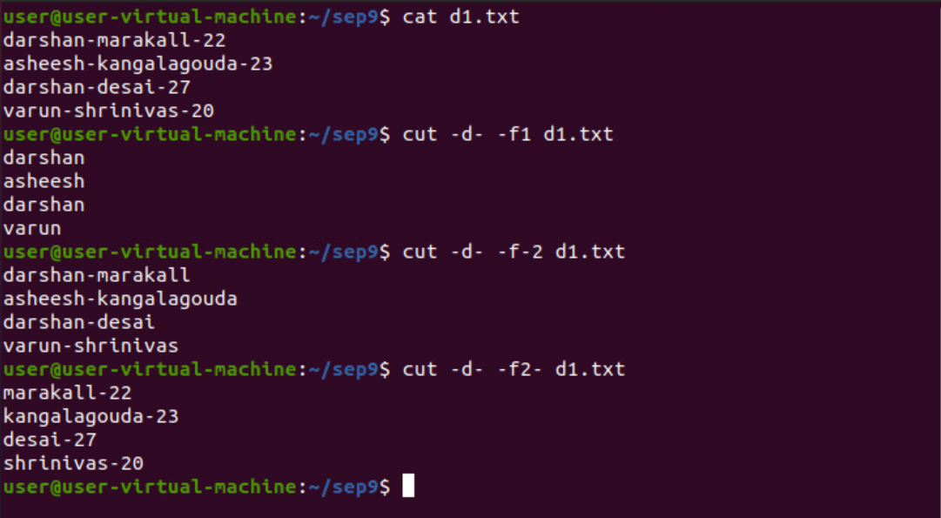
--complement ( As the name suggests it complement the output. This option can be used in the combination with other options either with -f or with -c. )
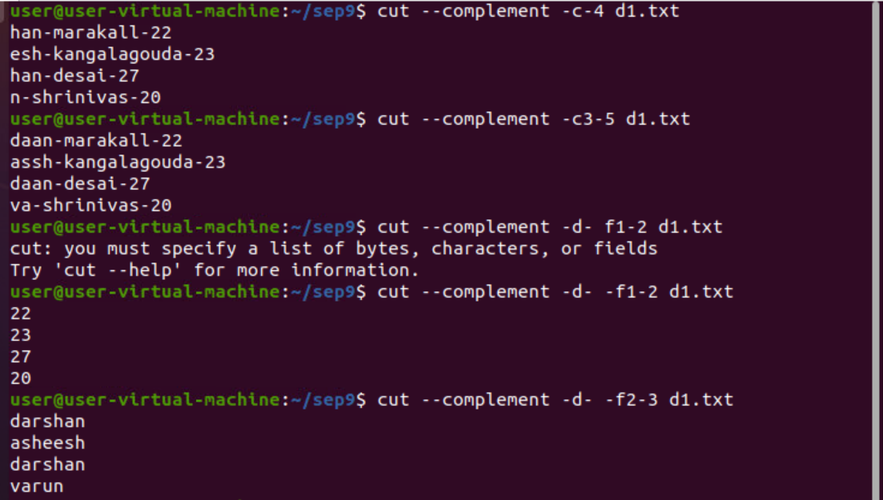
.
SORT:

sort file.txt – it will sort the content of file.txt in the ascending order

.

sort -r file.txt – it will sort the content of the file.txt in reverse order

.
sort -k field file.txt – it will sort the 2nd field in the ascending order
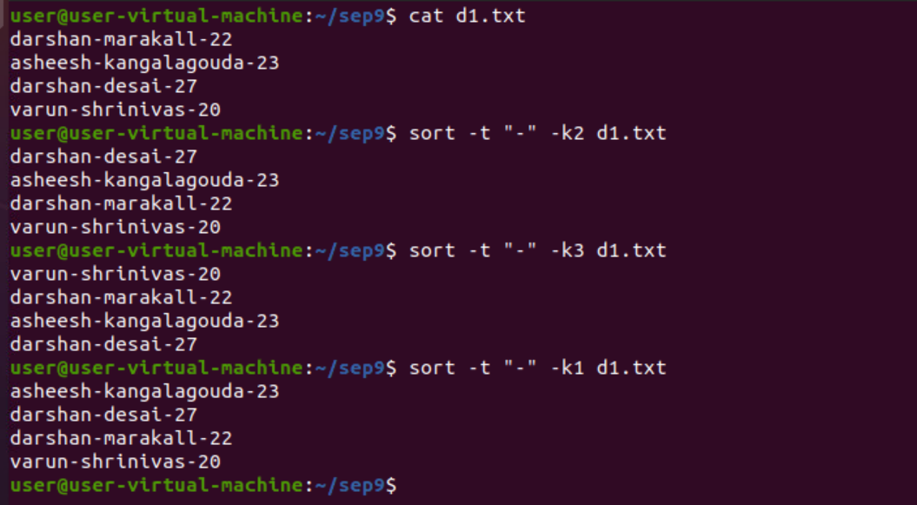
.

sort -u (sort and removes the duplicate items)
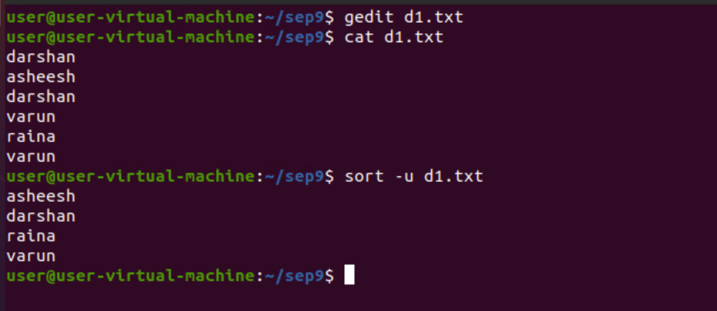
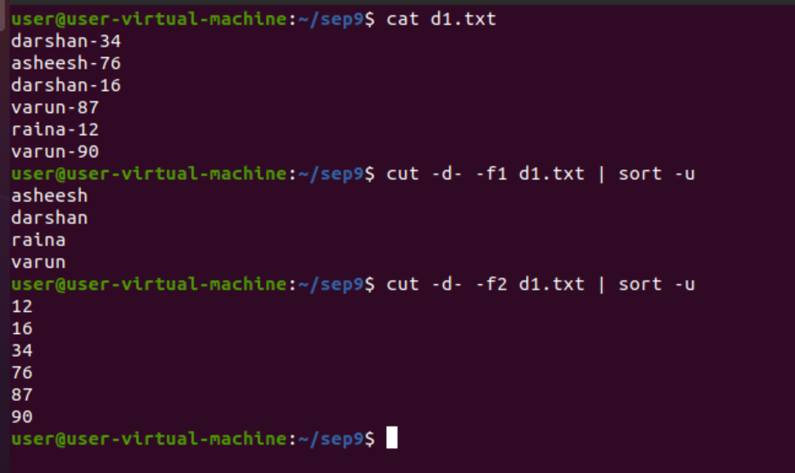
.

TR COMMANDS:
The tr command in UNIX is a command line utility for translating or deleting characters. It supports a range of transformations including uppercase to lowercase, squeezing repeating characters, deleting specific characters and basic find and replace. It can be used with UNIX pipes to support more complex translation. tr stands for translate.
. tr -d (it will helps in deleting the characters or number from the contents )
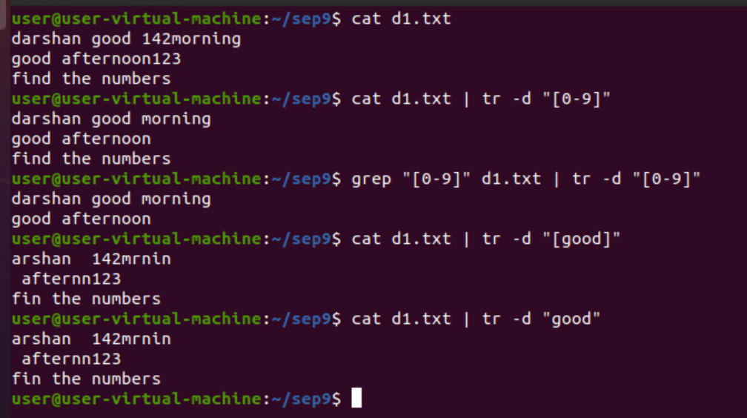
.

translate all the lower characters to upper characters. And translating all the spaces into -
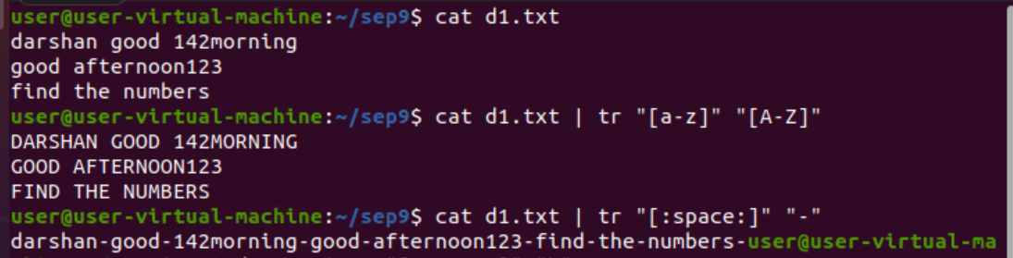
.

tr -s( squeezing all the spaces into single space:)
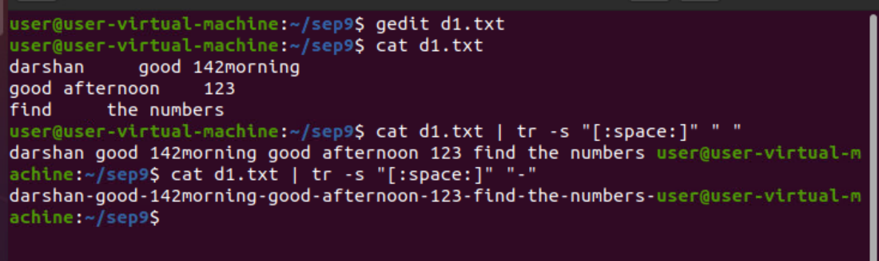
.
FIND COMMANDS:
find command will helps to find the directories/sub directories/files in the home directory

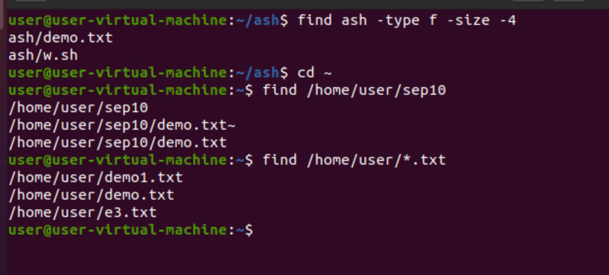
.

TREE: using tree command we can get all the paths of directories and subdirectories
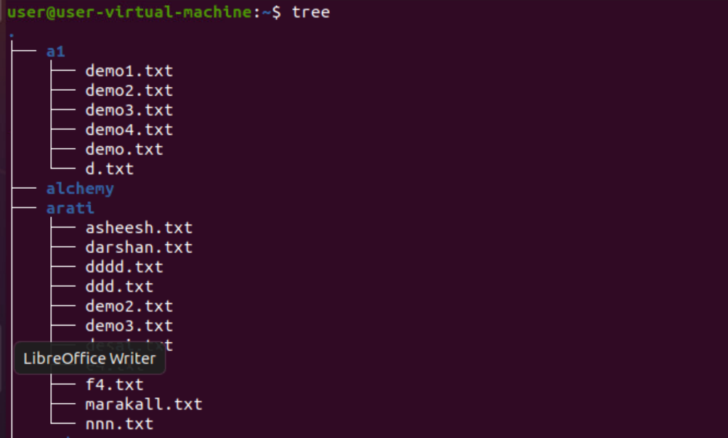
.
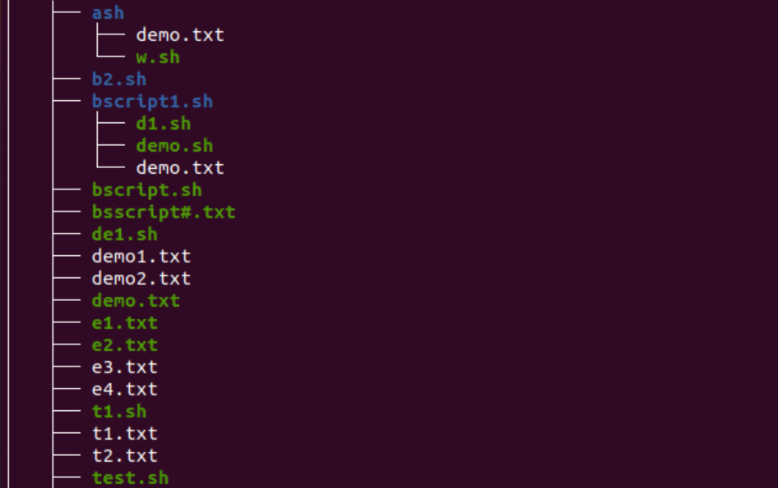
.
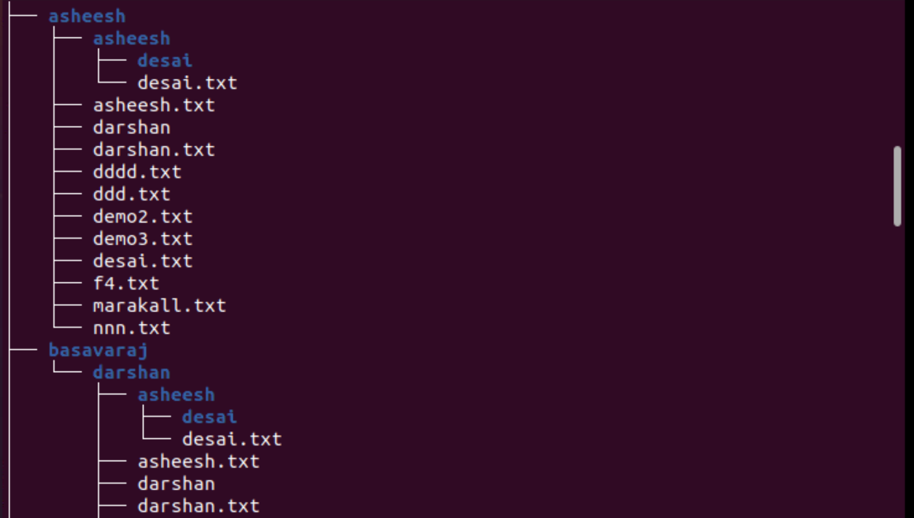
.
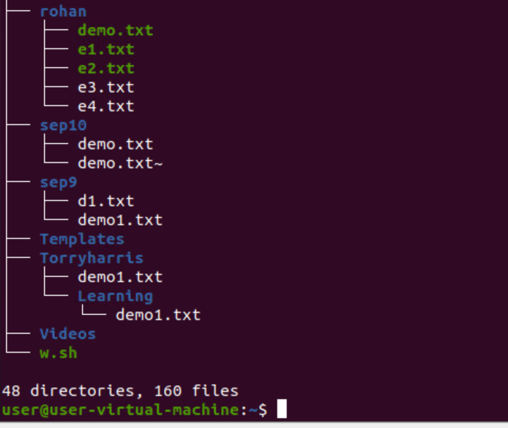
.

LESS:
searching words
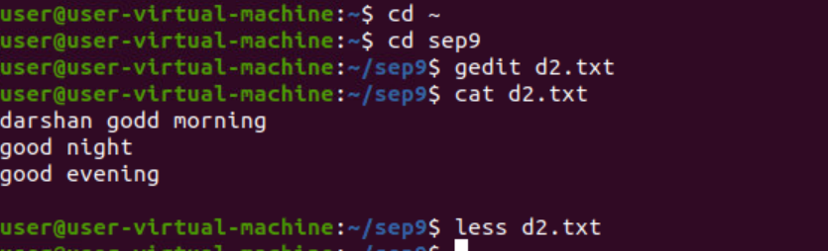
.

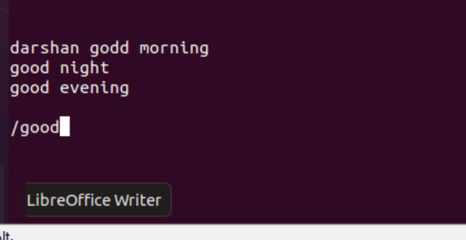
..

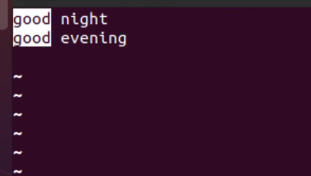
..

add line numbers using less command
less -N file.txt

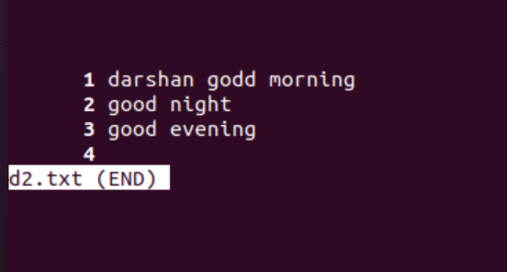

.
HEAD AND TAIL:
head
-n = number of lines
-c =bytes
-q =quit and combining two file contents
-v =verbose(display file name)
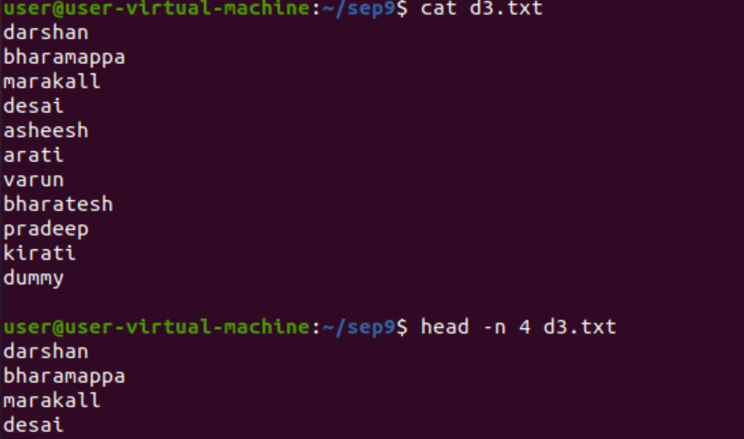
.

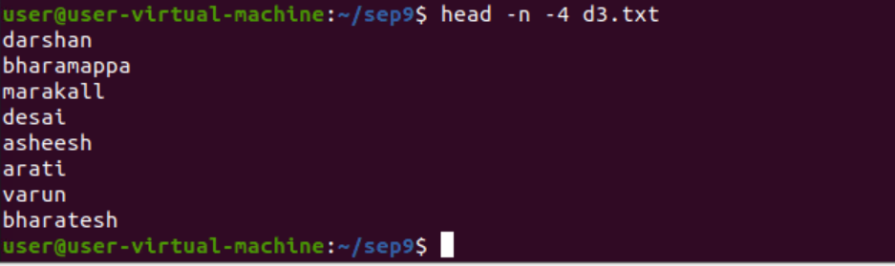
.
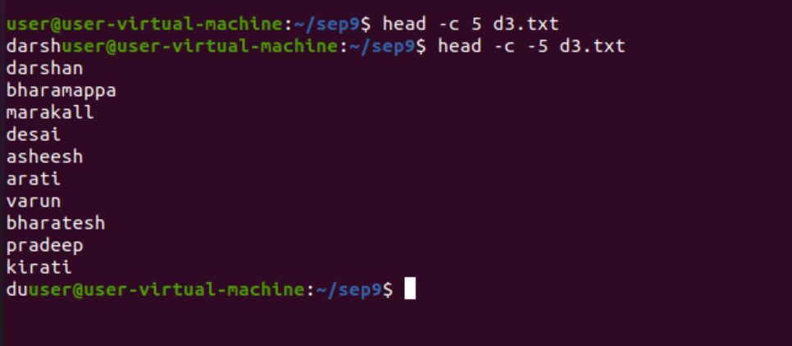
.
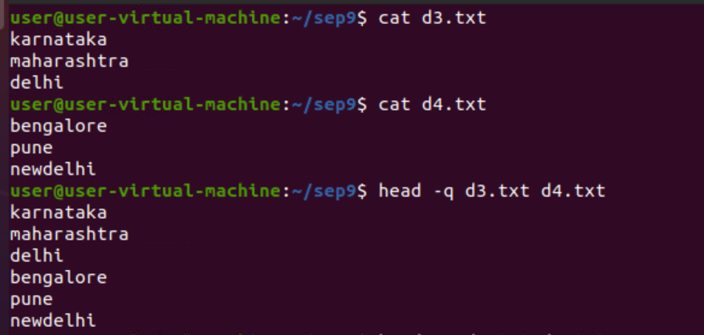
.

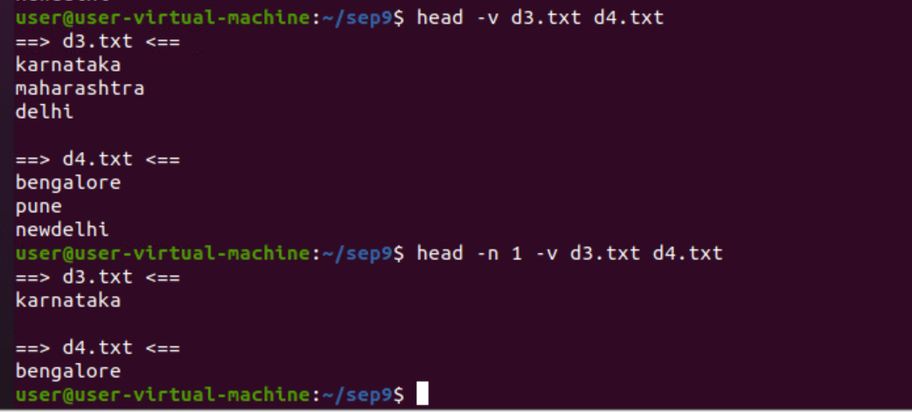
.
TAIL:
-n = print last n lines
-c =print last -c characters
-q =combining
-v= display file name
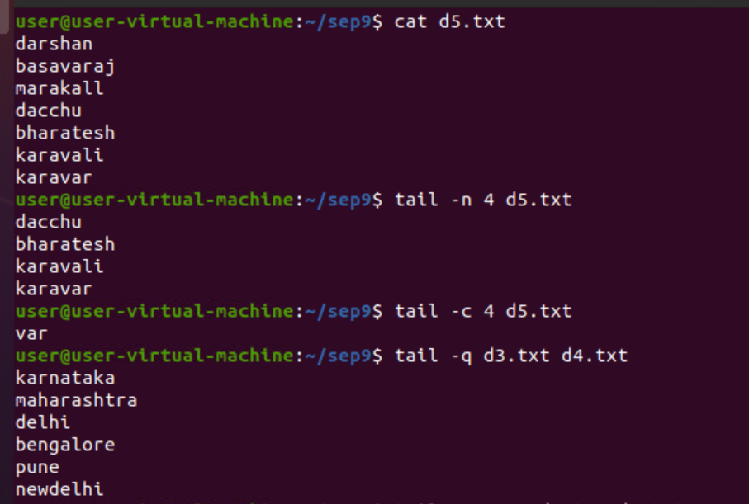
.
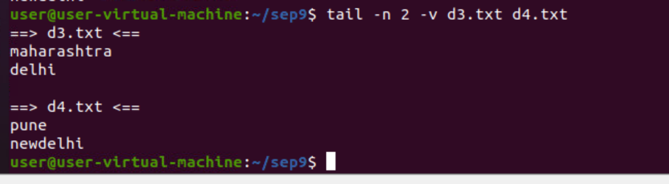
.

FILE PERMISSION:
- - - - - - - - - - = there are 10 character present
1st represent directory or file
next 3 character represents user/owner
next 3 character represents group
next 3 character represents other
and each user/group/other consist of 3 permissions i.e read, write, execute
a= all
u= user
x= execute
r= read
w= write
+= adding permissions
-= removing permissions
this can be done by using chmod command.
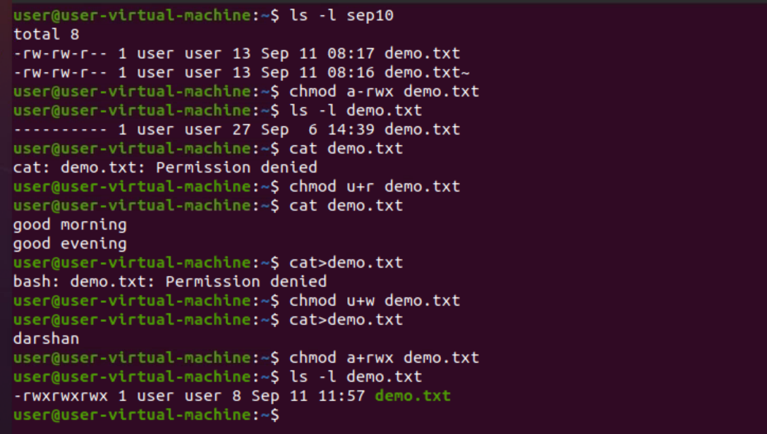
.
:SHELL SCRIPT:
1> print the content of the file using script
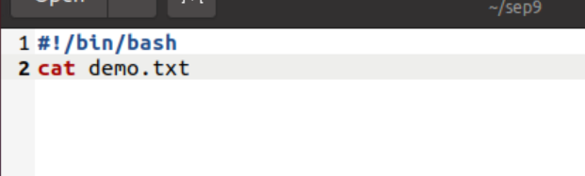
.

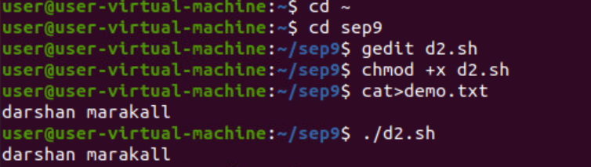
..

2> sort the content of the file in the natural order.
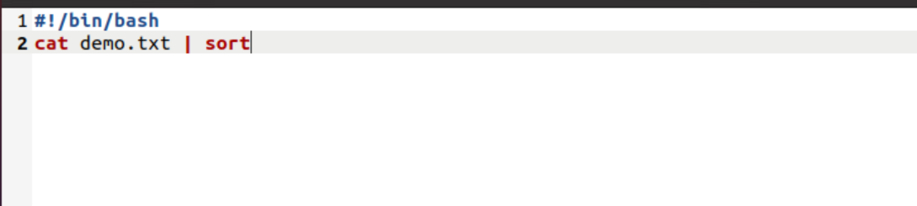
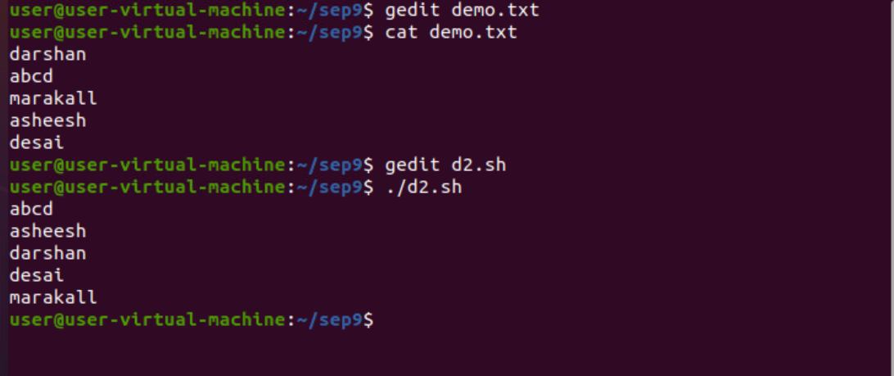
.
3> sort the content of the file in the reverse order
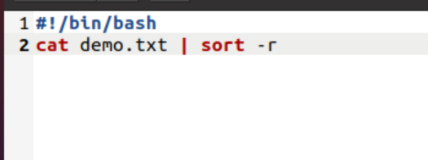
.

.
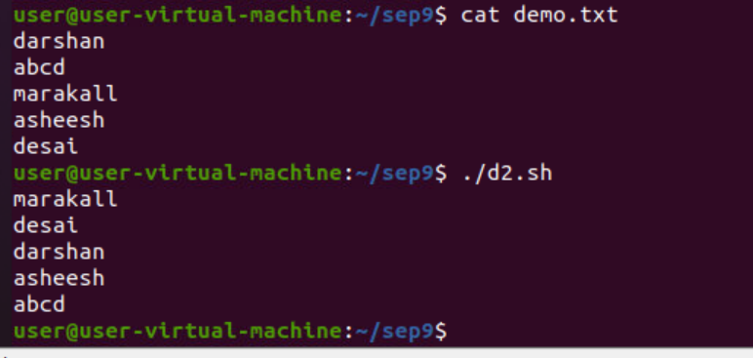
.

.4> print the entered number is odd or even
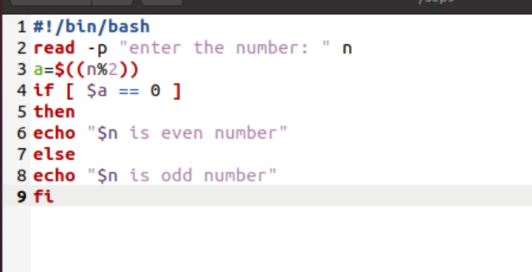
.

.
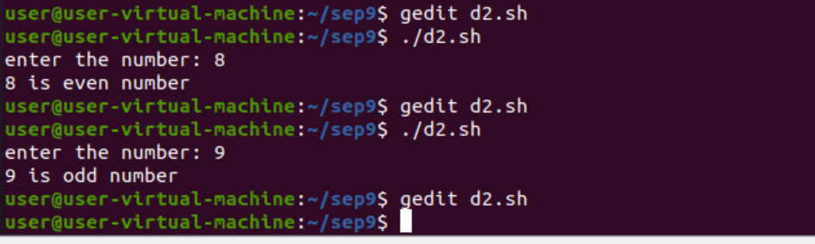
.
5> date format and week of the day
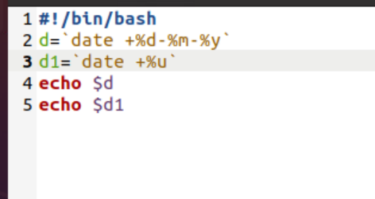
.

.
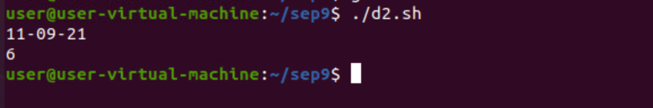
.

.
6> factorial of a number using for loop
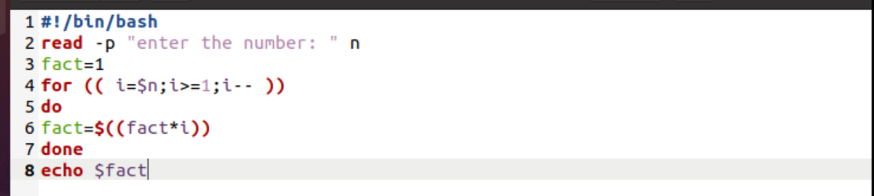
.

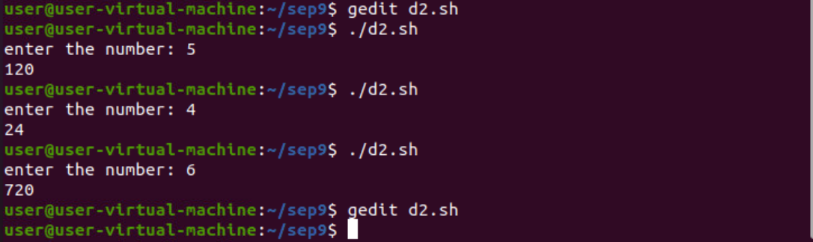
.
7> print the number is prime or not
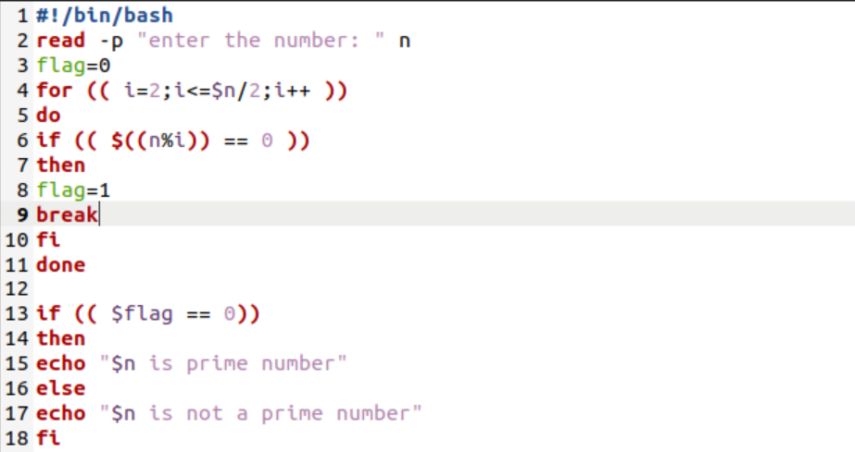
.
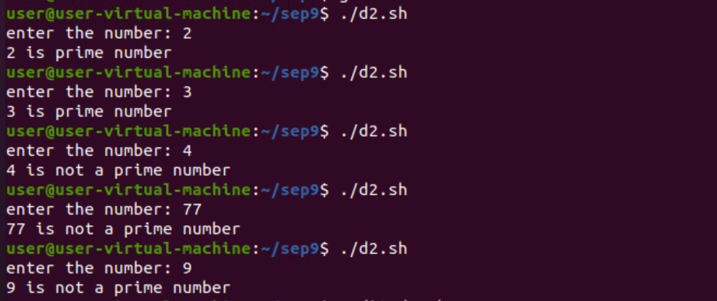
.
8> print the multiplication table using while loop
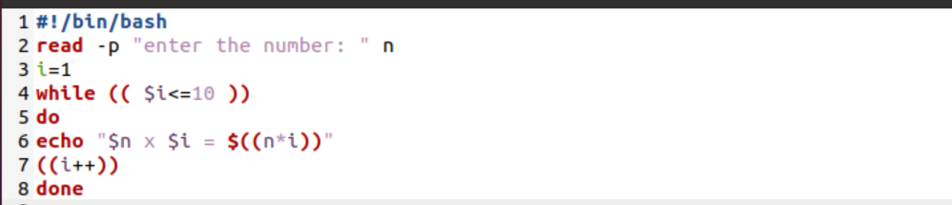
.
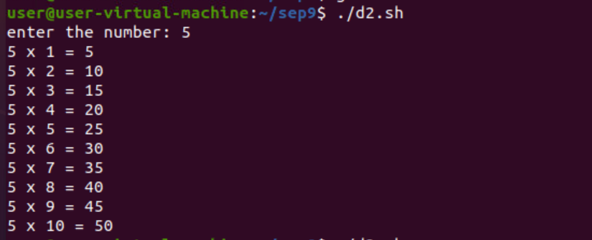
.

..

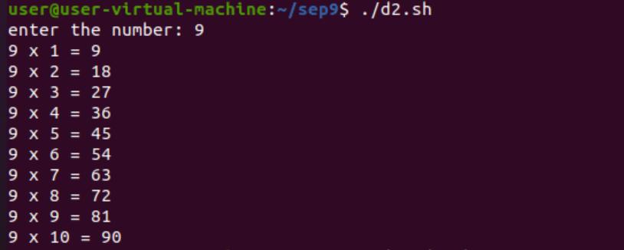
.
9> reverse the given number




